- Property Portal

"Live-In Realtors LLP" is a new real estate consultant company that deals with commercial and residential properties. They want to have a web page created which will allow their customers calculate the total amount to be paid on a property purchase, inclusive of GST. On submitting the details corresponding to the property, the total amount to be paid by a customer, has to be displayed on the same page as shown below.

Plain Web page design:
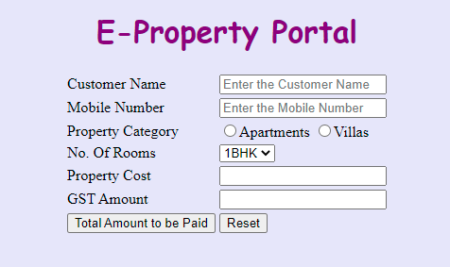

Web page after entering valid details and entering on “Total Amount to be Paid” button:
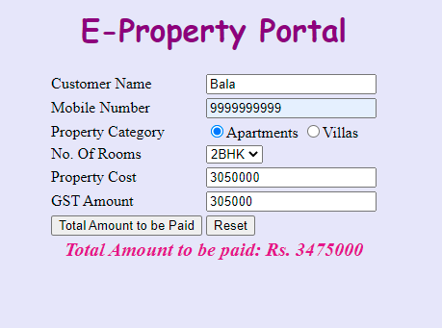

Use the Label Name and the Input Component Id as given. The Component Id can be given in any case (Upper case or Lower case or Mixed case). All the necessary attributes for the Components should be given. The Component Id should be specified for each HTML Component. If the Component Id is not provided for an HTML component, marks will not be provided for that component. All Tags, Elements and Attributes should conform to HTML5 Standards.

Provide the details as given in the table below.
Req. # | Req. Name | Req. Description
1 | Design an HTML page for “E-Property Portal” application | Note: The text highlighted in bold in the Description needs to be implemented in the code to complete the web page design.
  Label Name | Component ID  (Specify it for the “name” and “id” attribute) | Description
  Customer Name | customerName | To enter the name of the customer.  Design Constraints:  The text “Enter the Customer Name” should appear by default.  It should be mandatory.  Use type=“text” with pattern attribute to accept the alphabets and space only.
  Mobile Number | customerMobileNumber | To enter the mobile number of the customer.  Design Constraints:  The text “Enter the mobile number” should appear by default.  It should be mandatory.  Use type=“text” with pattern attribute to accept the 10 digit mobile number to start with either one of the following numbers: 7, 8 or 9
  Property Category | propertyCategory | To select the property category.  Design Constraints:  Use radio button to choose either Apartments or Villas  Do not specify ids for these 2 radio components.  It should be mandatory.  (set required on both)
  No. Of Rooms | noOfRooms | To select the number of rooms.  Design Constraints:  Use drop down box with “1BHK”, “2BHK ”and “3BHK” as the options.  The field is mandatory.
  Property Cost | propertyCost | This is a read only number type field which should automatically display the apartment/villa cost based on no. of rooms when the user clicks on this field. Check the table given below for cost details:
    1 BHK | 21,7,5000
    2 BHK | 30,50,000
    3 BHK | 45,00,000
  GST Amount | gstAmount | This is a read only number type field, which should display the GST amount to be paid when the user clicks on the field. GST amount should be calculated as 10% of the apartment/villa cost.
   | submit | Submit Button to submit the form  Design Constraints  The input type should be “submit”.  Value should be “Total Amount to be Paid ”
   | reset | On clicking this button, all fields should be reset. Value should be “Reset”
2 | Apply the mentioned styles using CSS to the components | STYLING WITH ELEMENT SELECTORS  - Body background-color should be “#E6E6FA”  - The heading "E-Property Portal" should be done using <h1> tag, the text color should be “#800080”, font family should be “cursive” and it should be aligned to center of the webpage.  STYLING WITH ID SELECTORS  The div tag with the id “total” to display the total amount paid should have font style as italic, color as #D03090 and font size as 20px. It should be center aligned with bold text.  Note: Fill in the style tag so as to have the given styles applied to the components. (Do not use Inline CSS)
3 | Use JavaScript for displaying the total amount details. | Use JavaScript for displaying the total amount details:  When the valid values are entered and the button component is clicked, the total monthly amount should be displayed as follows:  Total Amount to be paid: Rs. totalAmount  in a div tag with id “total”.  When the user clicks on the GST Amount field, GST amount must get calculated and get placed in this field. GST should be 10% of the apartment/villa cost.  Customer, on entering the valid values and on clicking on “Total Amount to be Paid” button, javascript method with calculation-logic has to get invoked. Total amount should be calculated as:  Apartment/Villa cost + GST amount + Registration cost + Corpus Fund  where: Registration cost is Rs. 1,00,000 and Corpus Fund is Rs. 20,000, for both appartment & villa.  Note:  - Use getElementsByName() or getElementById() function to retrieve the values.  - Please do not use “let”. Instead, use “var”.
4 | form Tag with attribute onsubmit | form Tag is already given in the code template. Do not change the code template and do the coding as per the requirements and specification.  JavaScript ‘function call’ to calculate property cost and gst amount is already given in the code template. Just implement these 2 functions.  Make sure that the onsubmit attribute in the form tag invokes the JavaScript function like "return calculateAmount()".  Also ensure that “return false;” statement should be the last line of the JavaScript function “calculateAmount()”.

Ph no. 9831602909(food delivery)

